

**CAPSTONE PROJECT REPORT**

**Report 5 – Software Test Documentation**

# **II. Project Management Plan**

## **1. Overall Description**

### **1.1 Test Model**

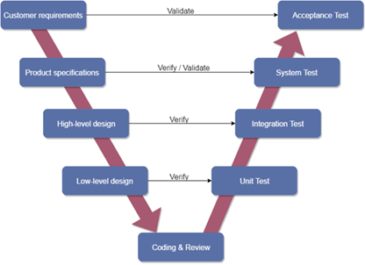

Overall, we choose V-Model to implement the testing process. With V-Model, software development is separated into two appropriate phase’s groups: development and testing. In this model, the verification and validation will be done side by side. It emphasizes the strict process flow to develop a quality product. The errors occurring in any phase will be corrected in that phase. Proactive defect tracking defects, which are found at early stages even, may be in the development phase before application being tested.

### **1.2 Testing Types**

The test team has to test the following type on Google Chrome browser and :

* GUI test
* Function test
* Acceptance test
* Unit test

|  |  |  |  |
| --- | --- | --- | --- |
| **Type of test** | **Stage of test** | | |
| **Integration test** | **System test** | **Acceptance test** |
| Unit test | x | x |  |
| GUI test |  | x | x |
| Function test | x | x | x |
| Acceptance test |  | x | x |

Table 5.1 – Test type

## **2. Test Plan**

### **2.1 Test Stages**

In this project, there are 3 phases in the testing process: Integration testing, System testing and Acceptance testing.

|  |  |  |
| --- | --- | --- |
| No. | Test Stages | Description |
| 1 | Integration testing | Integration testing allows individuals the opportunity to combine all of the units within a program and test them as a group. This testing level is designed to find interface defects between the modules/functions. This is particularly beneficial because it determines how efficiently the units are running together. |
| 2 | System testing | System testing is the first level in which the complete application is tested as a whole. The goal at this level is to evaluate whether the system has complied with all of the outlined requirements and to see that it meets Quality Standards. |
| 3 | Acceptance testing | Acceptance testing (or User Acceptance Testing), is conducted to determine whether the system is ready for release. During this phase, the tester and some alpha test users will test the system to find out whether the application meets their business’ needs. |

Table 5.2 – Testing stages

### **2.2 Resources**

#### ***a. Human Resources***

|  |  |  |
| --- | --- | --- |
| **Worker/Doer** | **Role** | **Specific Responsibilities/Comments** |
| VienMV |  | Make a Test plan, Create test reports |
| VanLT |  | Unit test |
| TungNT |  | Unit test |
| DungHV |  | System test |
| HoangNH |  | GUI test, System test |

#### 

#### ***b. Environment***

* Chrome 84.0.4147.135 (64-bit) DevTools: To view logs, inspect elements, lighthouse.

*Figure 2.2.1 - Chrome dev tools*

* Google sheet: To manage test documents

*Figure 2.2.2 - Google sheet*

* Microsoft Visual Studio 17: To run unit tests and create/ update code unit tests.

*Figure 2.2.3 - Microsoft visual*

* Apache JMeter 5.4.1: To test performance



*Figure 2.2.4 - Jmeter*

* Trello: To log bug and manager task

**

*Figure 2.2.5 - Trello*

|  |  |  |
| --- | --- | --- |
| **Type of testing** | **Software** | **Hardware** |
| System test & Acceptance test & Test case | * Google Sheet. * Google Docs. * Google Chrome 84.0.4147.135 (64-bit) | Personal computer for developing with the minimum configuration:  - Laptop Asus  - 2.20GHz Intel Core i7  - RAM: 16GB  Personal mobile phone for run testing with configuration:   * Samsung galaxy note 10 * Os: android 9.0 (pie) * Chip: Exynos 9825 * Ram: 8GB |
| Unit test | * Microsoft Visual Studio 2017 | Personal computer for run testing with minimum configuration:   * Laptop Asus rog gl552vx * Core i7 6700HQ 2.6GHz * RAM: 8GB |
| Performance Test | * Apache Jmeter 5.4.1 | Personal computer for run testing with minimum configuration:   * Laptop Asus rog gl552vx * Core i7 6700HQ 2.6GHz * RAM: 8GB |

*Table 2.2.5 – Testing Environment*

### **2.3 Features to be tested**

|  |  |  |
| --- | --- | --- |
| **ID** | **Use Case** | **Actors** |
| 01 | View newsfeed | Guest |
| 02 | Register | Guest |
| 03 | Login | Guest |
| 04 | Forgot password | User |
| 05 | Verification | User |
| 06 | Logout | User |
| 07 | View newsfeed | User |
| 08 | View post detail | User |
| 09 | Like post | User |
| 10 | Rate post | User |
| 11 | Comment post | User |
| 12 | Report post | User |
| 13 | Markup | User |
| 14 | Post a post | User |
| 15 | Update post | User |
| 16 | Delete post | User |
| 17 | Follow users | User |
| 18 | Unfollow users | User |
| 19 | Block users | User |
| 20 | Report users | User |
| 21 | View other user’s profile | User |
| 22 | Chat | User |
| 23 | Delete message in the conversation | User |
| 24 | Delete conversation | User |
| 25 | View list conversation | User |
| 26 | Search a conversation | User |
| 27 | View my profile | User |
| 28 | Update my profile | User |
| 29 | Search people | User |
| 30 | Search post | User |
| 31 | View list notification | User |
| 32 | View a notification | User |
| 33 | View hot posts | User |
| 34 | Recommend | User |
| 35 | Show suggest place of sale | User |
| 36 | View balance | User |
| 37 | Top up account | User |
| 38 | View list voucher | User |
| 39 | View voucher detail | User |
| 40 | Login | Manager |
| 41 | Logout | Manager |
| 42 | Create new staff | Manager |
| 43 | View list user | Manager |
| 44 | Search user | Manager |
| 45 | Ban user | Manager |
| 46 | Reset password for user | Manager |
| 47 | View list post | Manager |
| 48 | View post detail | Manager |
| 49 | Search user’s post | Manager |
| 50 | Delete post | Manager |
| 51 | Manage voucher | Manager |
| 52 | View list report | Manager |
| 53 | View report detail | Manager |
| 54 | Manage recommend data | Manager |
| 55 | Manage user’s balance | Manager |
| 56 | Manage my profile | Manager |

## 

### 2.4 Test process

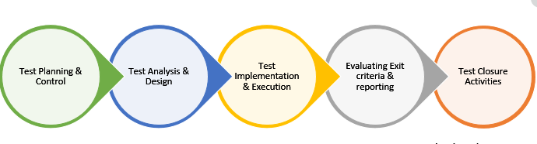

* Test Planning and Control use requirement specification test plans will make more detailed decisions about the overall approach of testing.
* Test Analysis and Design design and create test cases.
* Test Implementation and Execution: execute test procedures using test execution tools, check actual results with expected results.
* Evaluating exit criteria and Reporting defines when to stop testing based on time.
* Test closure activities update Test Report and if there is an error then report error.

### 2.4 Test schedule

The table below describes the test schedule for the SoFa Project:

|  |  |  |  |
| --- | --- | --- | --- |
| **Test Schedule** | **Start Date** | **End Date** | **Responsibilities** |
| Unit test | April 04, 2021 | April 18, 2021 | TungNT, VanLT |
| GUI test | Match 18, 2020 | Match 22, 2020 | VienMV, HoangNH |
| System test | Match 18, 2020 | April 29, 2021 | VienMV, HoangNH, DungHV, |
| Acceptance test | April 18, 2021 | April 26, 2021 | User |

*Table 2.4 – Test schedule*

## **3. Test Cases**

Test cases have been managed on the [Test Case Sheet](https://drive.google.com/file/d/1X_9vBe1qs53Yzc2_xQe72vfOo2-Vw9uE/view?usp=sharing). These are some example images about the Test cases below:

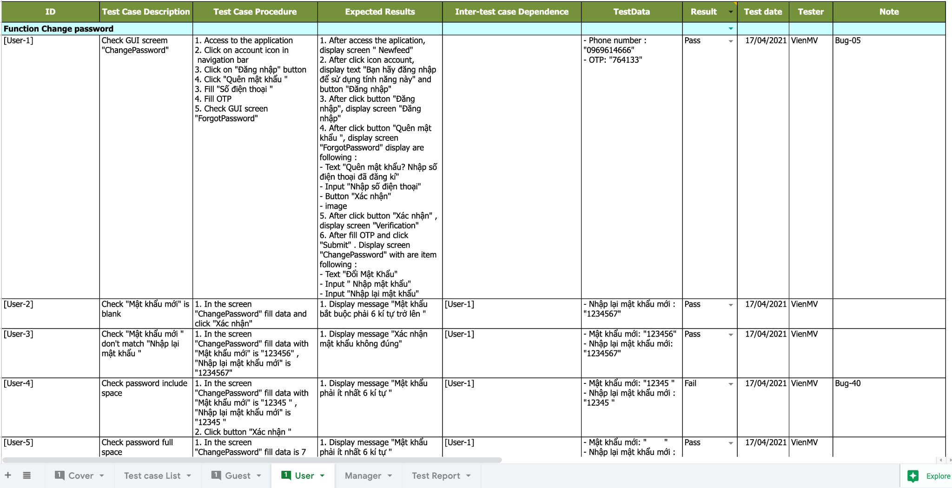

*Figure 3.1 - Test case for change password*

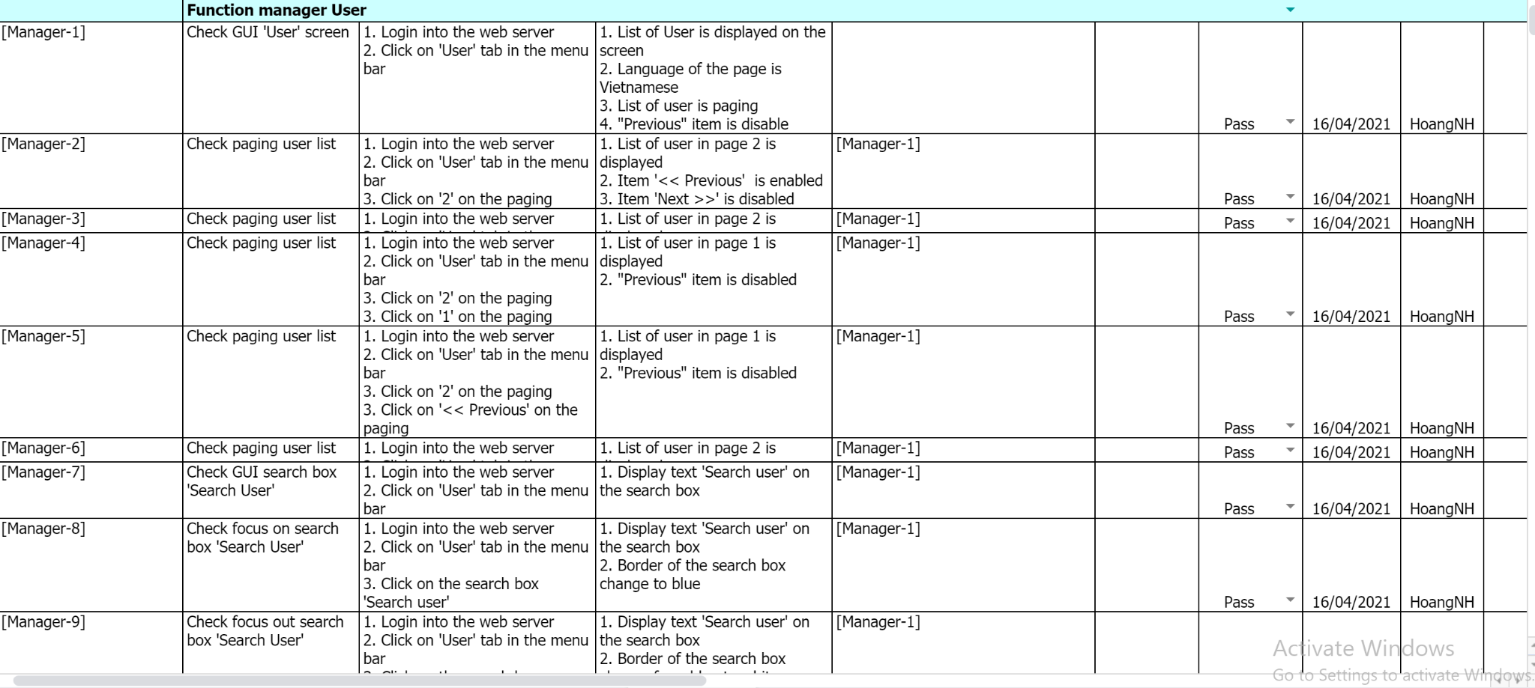

*Figure 3.2 - Test case for function manager user*

## 4. Checklists

|  |  |  |  |
| --- | --- | --- | --- |
| ID | Checklists | Yes | No |
|  | General |  |  |
| CL-01 | Functionality of buttons available on all screen, | √ |  |
| CL-02 | Validation error messages are displayed properly below the field. | √ |  |
| CL-03 | All numeric values are formatted properly. | √ |  |
| CL-04 | All error messages are displayed using red color. | √ |  |
| CL-05 | Delete functionality for any record on the page is asked for confirmation. | √ |  |
| CL-06 | Text does not have grammatical and spelling errors. | √ |  |
| CL-08 | Feature buttons on all page displays with the right role of users. | √ |  |
| CL-09 | All mandatory fields are validated and required. | √ |  |
|  | GUI and Usability |  |  |
| CL-10 | Information is presented in the order that the user needs it. | √ |  |
| CL-11 | All fields on page (e.g. text box, radio options, dropdown lists) should be aligned properly. | √ |  |
| CL-12 | The text is easy to understand. Don't use slang, acronyms, and abbreviations. | √ |  |
| CL-13 | Icons and images are designed to give impression and copyright. | √ |  |
| CL-14 | The most important fields are located where they are easy to see. | √ |  |
|  | Database |  |  |
| CL-15 | Input date of birth cannot be greater than current date. | √ |  |
| CL-16 | Null values are not allowed for Primary key columns. | √ |  |
| CL-17 | Radio button options are saved correctly in the database with true/false. | √ |  |
| CL-18 | Input data is not truncated. Field length shown to the user on page and in database schema should be the same. | √ |  |
| CL-19 | Input numeric fields with minimum, maximum, and float values. | √ |  |
| CL-20 | Input date is formatted dd/mm/yyyy | √ |  |
| CL-21 | Database fields are designed with correct data type and data length. | √ |  |
| CL-22 | Input field leading and trailing spaces are truncated before committing data to the database. | √ |  |
| CL-23 | Fields of columns are unique then cannot duplicate. | √ |  |
|  | Security |  |  |
| CL-24 | Test login with google authenticator. | √ |  |
| CL-25 | Do not save all information of the account logged, but only save uuid in session. | √ |  |

*Table 5.5 – Checklist*

## 5. Test Reports

* Test report has been manage on the [Test report sheet](https://docs.google.com/spreadsheets/d/1X_9vBe1qs53Yzc2_xQe72vfOo2-Vw9uE/edit#gid=1789090907)